SIMATS ENGINEERING

ASSESSMENT TOOL 2: Scenario-Based Research Assessment

COURSE NAME: ARTIFICIAL INTELLIGENCE COURSE CODE: MLA01 AND EXPERT SYSTEMS

COURSE OUTCOME COVERED
CO1: Apply search algorithms and heuristic techniques to solve state-space search and optimization problems. (BTL 3)
Assessment Tool Weightage: 45 %

Total Marks: 50 Time: 60 Mins
No. of Questions: 5
Annexure A

Scenario-Based Research Assessment

Code of Conduct:

I Uppu Sye Kumar(192325121) (Name / Reg No) certify that this submission is my original work and that I have adhered to the guidelines specified for this assessment. I understand that any violation of academic integrity rules will result in disciplinary action.

Signature of the student: Syekumar

Criterion | Weightage | Marks Obtained
Identification of Latest AI Application | 10%
Problem Analysis and Domain Understanding | 15%
AI Technologies and Working Mechanism | 20%
Research Quality and Literature Review | 10%
Real-World Implementation and Case Analysis | 10%
Impact, Challenges, and Future Scope | 15%
Originality and Critical Thinking | 10%
Organization, Presentation, and Documentation | 10%
Total | 100%

Signature of the Faculty Total Marks Awarded

ANSWER ANY ONE

No. | AI Domain | Scenario-Based Research Question
1 | Healthcare | Healthcare organizations are increasingly adopting Artificial Intelligence to improve diagnosis, treatment, and patient monitoring. Identify and research a latest AI-based application in healthcare (such as AI-assisted medical diagnosis, AI radiology systems, robotic surgery, AI drug discovery, or virtual healthcare assistants). Analyze its working principles, AI techniques used, real-world implementation, benefits, and limitations.
2 | Finance | Financial institutions are leveraging Artificial Intelligence to enhance security, decision-making, and customer services. Identify and research a latest AI application in the finance domain (such as AI fraud detection systems AI-powered financial advisors, algorithmic trading platforms, or intelligent banking assistants). Discuss its functionality, technologies involved, advantages, and challenges.
3 | Retail | Retail companies are adopting AI-driven solutions to provide personalized and intelligent shopping experiences. Identify and research a latest AI application in retail (such as Generative AI shopping assistants, AI recommendation engines virtual try-on systems, or AI-based demand forecasting). Explain its application, AI methods used, impact on customers and businesses, and future scope.
4 | Autonomous Vehicles | The transportation sector is rapidly evolving with AI-based autonomous systems. Identify and research a latest AI application in autonomous vehicles (such as self-driving technology, AI-based perception systems, autonomous delivery vehicles, or intelligent traffic management). Analyze the AI technologies involved, real-world deployment, benefits, and challenges.
5 | Robotics | Intelligent robots are being developed for applications in industries, healthcare, education, and daily life. Identify and research a latest AI application in robotics (such as humanoid robots, collaborative robots, service robots, or AI-powered warehouse robots). Explain their capabilities, AI techniques, real-world usage, and future developments.
6 | Manufacturing | Manufacturing industries are integrating AI to achieve smart and automated production environments. Identify and research a latest AI application in smart manufacturing (such as AI-based predictive maintenance, computer vision quality inspection, digital twins, or autonomous manufacturing systems). Discuss its working, industrial applications, advantages, and limitations.

1. Introduction
Autonomous Vehicles (AVs), commonly called self-driving cars, are one of the most advanced applications of Artificial Intelligence (AI). These vehicles can navigate roads, detect obstacles, obey traffic rules, and reach destinations with minimal or no human intervention.
Modern autonomous vehicles combine AI, Machine Learning (ML), Deep Learning (DL), Computer Vision, Sensor Fusion, and Reinforcement Learning to perceive their surroundings and make real-time driving decisions.
The goal of autonomous driving is to make transportation safer, smarter, more efficient, and environmentally friendly.

2. What are Autonomous Vehicles?
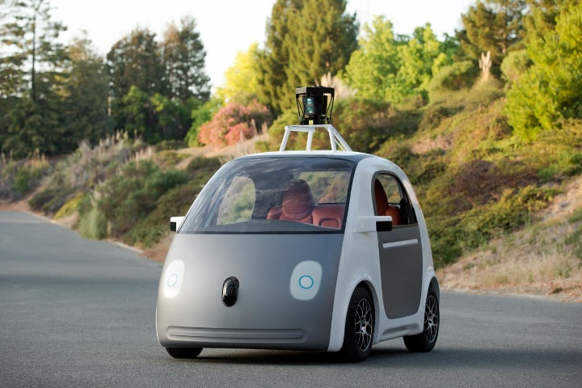
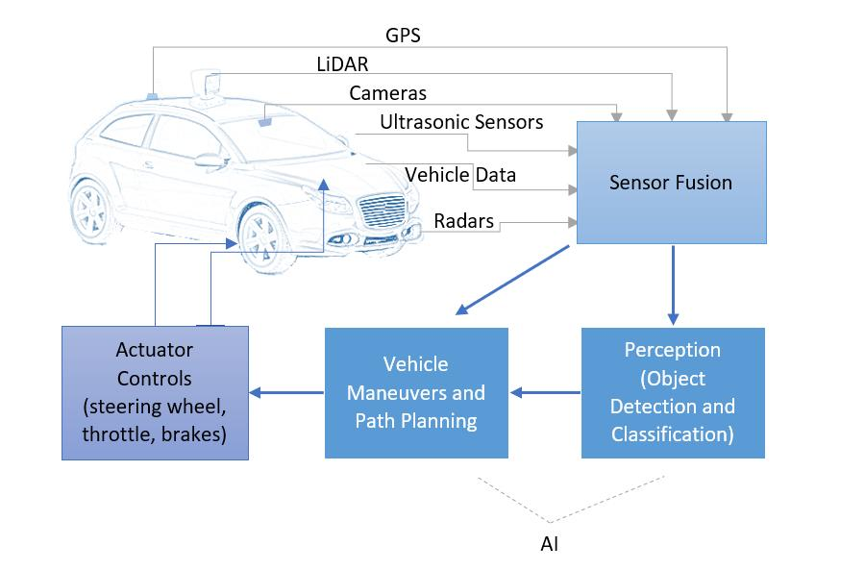
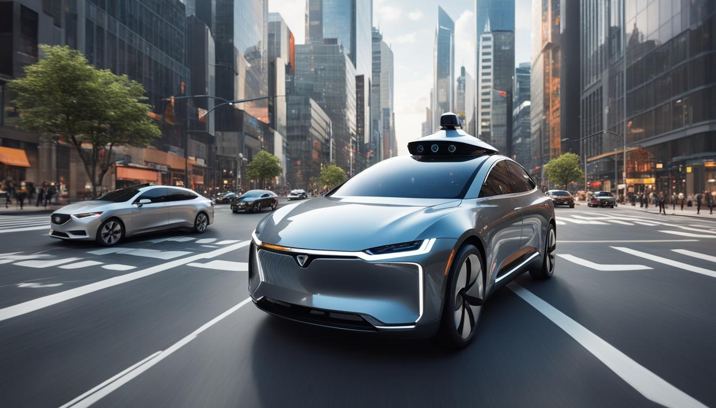

7
An Autonomous Vehicle (AV) is a vehicle capable of sensing its environment and driving itself without continuous human control.
Main Features
- Self-driving capability
- Obstacle detection
- Lane keeping
- Adaptive cruise control
- Automatic braking
- Traffic sign recognition
- Route planning
- Parking assistance

3. Evolution of Autonomous Vehicles
Manual Driving
│
▼
Driver Assistance (ADAS)
│
▼
Semi-Autonomous Driving
│
▼
Highly Autonomous Driving
│
▼
Fully Autonomous Vehicles

Levels of Automation
Level | Description
Level 0 | Manual driving
Level 1 | Driver Assistance
Level 2 | Partial Automation
Level 3 | Conditional Automation
Level 4 | High Automation
Level 5 | Fully Autonomous

4. AI Technologies Used in Autonomous Vehicles
AI Technology Overview
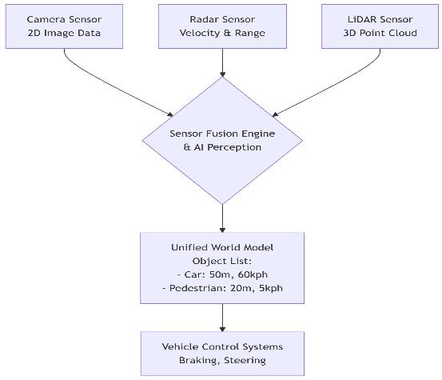
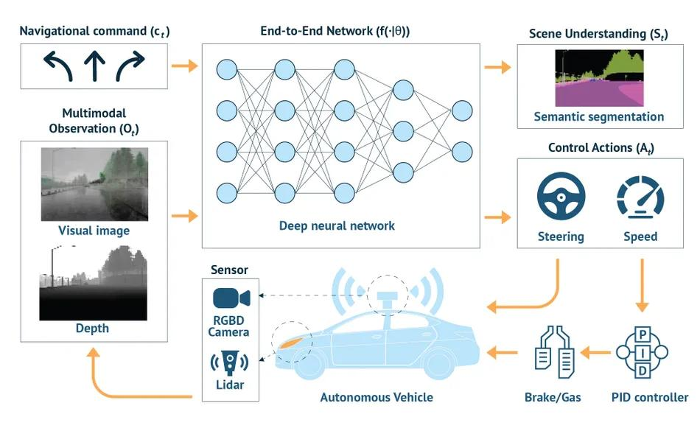
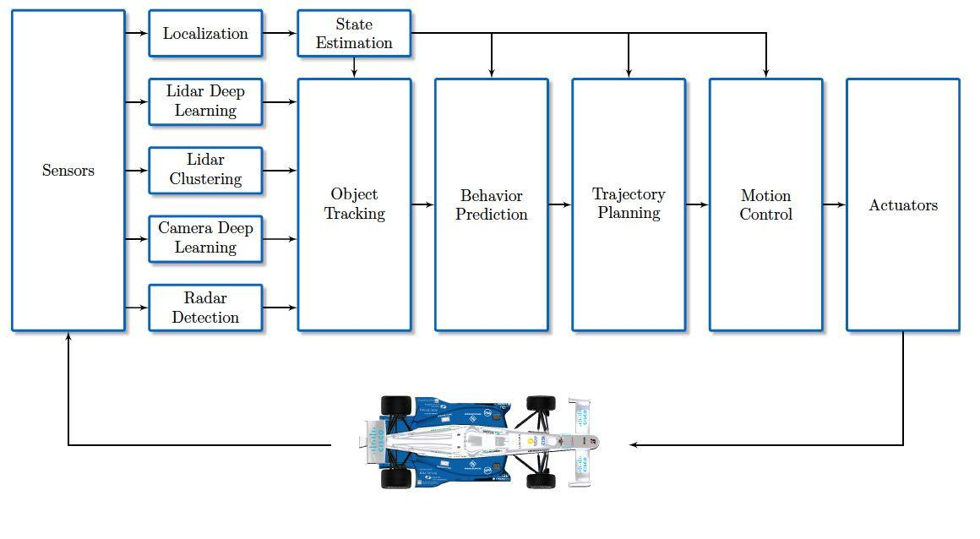
7
(A) Computer Vision
Computer Vision enables vehicles to understand their surroundings using cameras.
Functions include:
- Detecting pedestrians
- Recognizing traffic lights
- Lane detection
- Object detection
- Sign recognition
Algorithms Used
- YOLO
- Faster R-CNN
- SSD
- Mask R-CNN

(B) Deep Learning
Deep Neural Networks analyze images and sensor data to make driving decisions.
Applications:
- Image classification
- Road segmentation
- Driver behavior prediction
- Object recognition
Popular Models:
- CNN
- ResNet
- EfficientNet
- Vision Transformer (ViT)

(C) Sensor Fusion
Sensor fusion combines information from multiple sensors.
Sensors include:
- Camera
- LiDAR
- Radar
- Ultrasonic Sensors
- GPS
- IMU (Inertial Measurement Unit)
Benefits:
- Higher accuracy
- Better obstacle detection
- Improved reliability
- Reduced sensor errors

(D) Reinforcement Learning
The vehicle continuously learns the best driving actions through interaction with the environment.
Applications:
- Route optimization
- Overtaking
- Parking
- Traffic navigation

(E) Natural Language Processing (NLP)
Allows interaction using voice commands.
Example:
"Navigate to the nearest hospital."

(F) Path Planning Algorithms
Used to determine the safest and shortest path.
Examples:
- A* Search
- Dijkstra Algorithm
- Rapidly Exploring Random Trees (RRT)
- Hybrid A*

5. Autonomous Vehicle Architecture
System Architecture
Sensors
(Camera, LiDAR, Radar, GPS)

│
▼

Data Collection

│
▼

Sensor Fusion

│
▼

AI Perception System

│
▼

Object Detection & Classification

│
▼

Localization & Mapping (HD Maps)

│
▼

Path Planning & Decision Making

│
▼

Vehicle Control System

│
▼

Steering | Brake | Acceleration

6. AI Working Flow
Complete Autonomous Driving Workflow
Start

↓

Capture Environment

↓

Collect Sensor Data

↓

Image Processing

↓

Object Detection

↓

Lane Detection

↓

Traffic Sign Recognition

↓

Sensor Fusion

↓

Localization

↓

Path Planning

↓

Decision Making

↓

Vehicle Control

↓

Reach Destination

↓

End
Decision Flowchart
Start
│
▼
Read Sensor Data
│
▼

Detect Obstacles?

Yes No

│ │
▼ ▼
Identify Object Continue
│
▼
Safe to Continue?

Yes No
│ |
▼ ▼
Continue Brake / Stop
│
▼
Plan New Route
│
▼
Drive Forward
│
▼
Destination Reached
│
▼

End

7. AI Components in an Autonomous Vehicle
AI SYSTEM

│
┌────────────────┼─────────────────┐

▼ ▼ ▼

Perception Planning Control

│ │ │

Detect Objects Route Planning Steering

Lane Detection Speed Control Braking

Traffic Signs Navigation Acceleration

8. Real-World Deployment
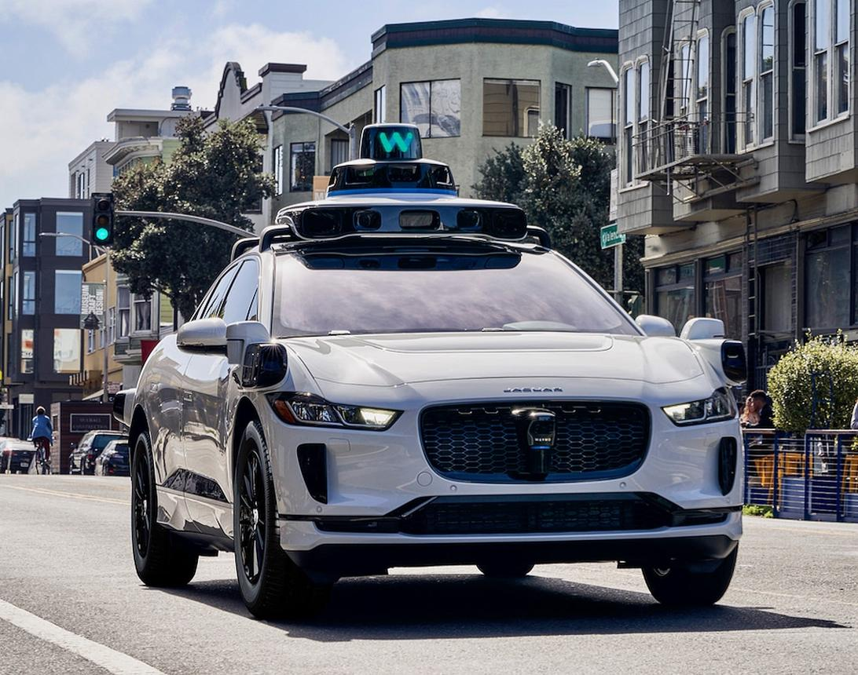
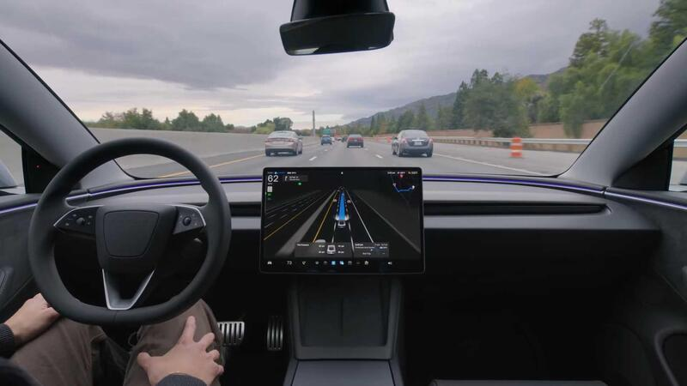
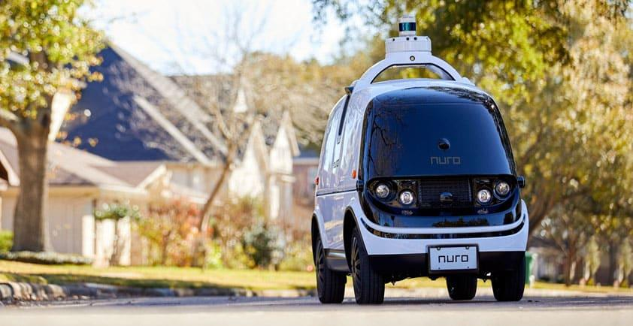
4
Several companies have successfully deployed AI-based autonomous

vehicles:
Company | AI Application
Waymo | Autonomous Robotaxi
Tesla | Full Self-Driving (FSD)
Mercedes-Benz | Drive Pilot (Level 3)
Cruise | Autonomous Taxi
Nuro | Autonomous Delivery Vehicle
Baidu Apollo | Robotaxi & Smart Transportation
Examples
Waymo
- Fully autonomous taxi service operating in selected cities.
Tesla
- AI-based Full Self-Driving (FSD) system using cameras and neural networks.
Nuro
- Autonomous delivery vehicles for groceries and food.
Mercedes-Benz
- Level 3 autonomous driving approved in specific regions under defined conditions.

9. Benefits of AI-Based Autonomous Vehicles

Benefits

│

┌─────────────┼──────────────┐

▼ ▼ ▼

Safety Efficiency Comfort

▼ ▼ ▼

Less Less Traffic Automatic

Accidents Fuel Saving Driving

Reduced Pollution

Smart Parking

24×7 Delivery

Reduced Driver Fatigue
Major Advantages
- Reduces human driving errors
- Enhances road safety
- Improves traffic flow
- Saves fuel through optimized driving
- Enables mobility for elderly and disabled individuals
- Supports autonomous logistics and deliveries

10. Challenges
Challenge | Description
Bad Weather | Rain, fog, and snow reduce sensor accuracy
Ethical Decisions | Handling unavoidable accident scenarios
Cybersecurity | Protection against hacking
High Cost | Expensive sensors and computing hardware
Legal Issues | Regulations vary across countries
Complex Traffic | Difficulties in mixed traffic environments
Infrastructure | Requires HD maps and smart road infrastructure

11. Future Scope
Future advancements in AI-based autonomous vehicles include:
- Vehicle-to-Vehicle (V2V) communication
- Vehicle-to-Infrastructure (V2I) communication
- AI-powered smart traffic management
- Autonomous public transportation
- Drone and robot delivery integration
- 5G-enabled cooperative driving
- Edge AI for faster real-time decision making
- Green autonomous electric vehicles

12. Conclusion
Artificial Intelligence is revolutionizing the transportation industry through autonomous vehicles. By integrating Computer Vision, Deep Learning, Sensor Fusion, Reinforcement Learning, and intelligent planning algorithms, self-driving vehicles can perceive their surroundings, make real-time decisions, and navigate safely with minimal human intervention. Real-world deployments by companies such as Waymo, Tesla, Mercedes-Benz, Cruise, Nuro, and Baidu demonstrate the practical potential of autonomous driving. Although challenges related to safety, regulations, cybersecurity, and environmental conditions remain, continued advancements in AI, high-performance computing, and smart infrastructure are expected to accelerate the adoption of autonomous vehicles, making transportation safer, more efficient, and more sustainable.

References
- S. Thrun et al., "Stanley: The Robot that Won the DARPA Grand Challenge," Journal of Field Robotics.
- C. Urmson et al., "Autonomous Driving in Urban Environments," Journal of Field Robotics.
- SAE International. Taxonomy and Definitions for Terms Related to Driving Automation Systems (J3016).
- Goodfellow, Bengio, & Courville. Deep Learning. MIT Press.
- Geiger, A., Lenz, P., & Urtasun, R. "The KITTI Vision Benchmark Suite."
- Research papers from IEEE Xplore and Springer on autonomous driving, perception systems, and intelligent transportation systems (2022–2025).

Rubrics for Evaluation
S.No | Criteria | Weightage (%) | Excellent (100–90%) | Good (89–75%) | Satisfactory (74–60%) | Improvement (
1. | Identification of Latest AI Application | 10% | Selects a highly relevant, emerging AI application with strong justification. | Selects a recent and relevant AI application. | Selects a suitable application with limited justification. | Application is outdated or irrelevant.
2. | Problem Analysis and Domain Understanding | 15% | Clearly explains the real-world problem, domain context, and need for AI with critical analysis. | Good explanation with adequate analysis. | Basic explanation with limited analysis. | Problem statement is unclear or incomplete.
3. | AI Technologies and Working Mechanism | 20% | Accurately explains AI techniques, algorithms, architecture, and workflow with technical depth. | Good explanation with minor omissions. | Covers only basic AI concepts. | AI technologies are poorly explained or incorrect.
4. | Research Quality and Literature Review | 10% | Uses recent, credible sources with proper citations and excellent synthesis. | Good quality references with appropriate citations. | Limited references with basic discussion. | Few or unreliable references; poor citation.
5. | Real-World Implementation and Case Analysis | 10% | Thoroughly analyzes industrial implementation with appropriate examples. | Good implementat ion analysis. | Basic implementation discussion. | Minimal or no real-world analysis.
6. | Impact, Challenges, and Future Scope | 15% | Critically evaluates benefits, limitations, ethical issues, and future trends. | Good evaluation with minor gaps. | Basic discussion of impact and future scope. | Limited evaluation or missing sections.
7. | Originality and Critical Thinking | 10% | Demonstrates independent research, innovation, and critical evaluation. | Good analytical thinking. | Some originality with limited analysis. | Mostly descriptive or copied content.
8. | Organization, Presentation, and Documentation | 10% | Exceptionally organized, professional presentation, error-free, and properly referenced. | Well organized with minor issues. | Adequately organized with some errors. | Poor organization and documentation.

